KOSGEB Support Programs from Idea to Market

KOSGEB Support Programs from Idea to Market

Dr. Uğur CORUH

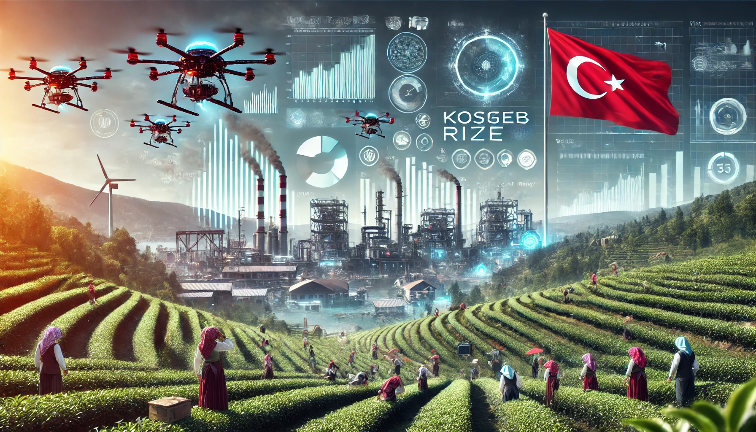

## Download Files

* [PDF PRESENTATION](girisimcilik-giris.marp.pdf)
* [PPTX PRESENTATION](girisimcilik-giris.marp.pptx)
* [PDF DOCUMENT](girisimcilik-giris.pandoc.pdf)
* [WORD DOCUMENT](girisimcilik-giris.pandoc.docx)

# KOSGEB Support Programs from Idea to Market

### **What is a project?** → **How to Get Support?** → **How to Start?** → **Develop, Grow, Commercialize!**

**Learn the steps to grow your business through projects!**

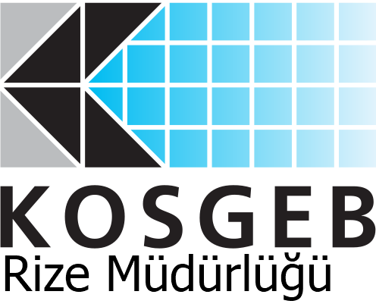    

#### **Dr. Uğur CORUH**

* **General Manager, Coruh Arge ve Teknoloji**
* **Lecturer, Recep Tayyip Erdoğan University, Computer Engineering**

### **What is a Project and Why is it Important?**



A project is a planned effort aimed at achieving a specific goal, such as growing your business, introducing new products, or increasing efficiency.

* Purpose
* Goal
* Plan
* Action
* Result

### **Project Elements**

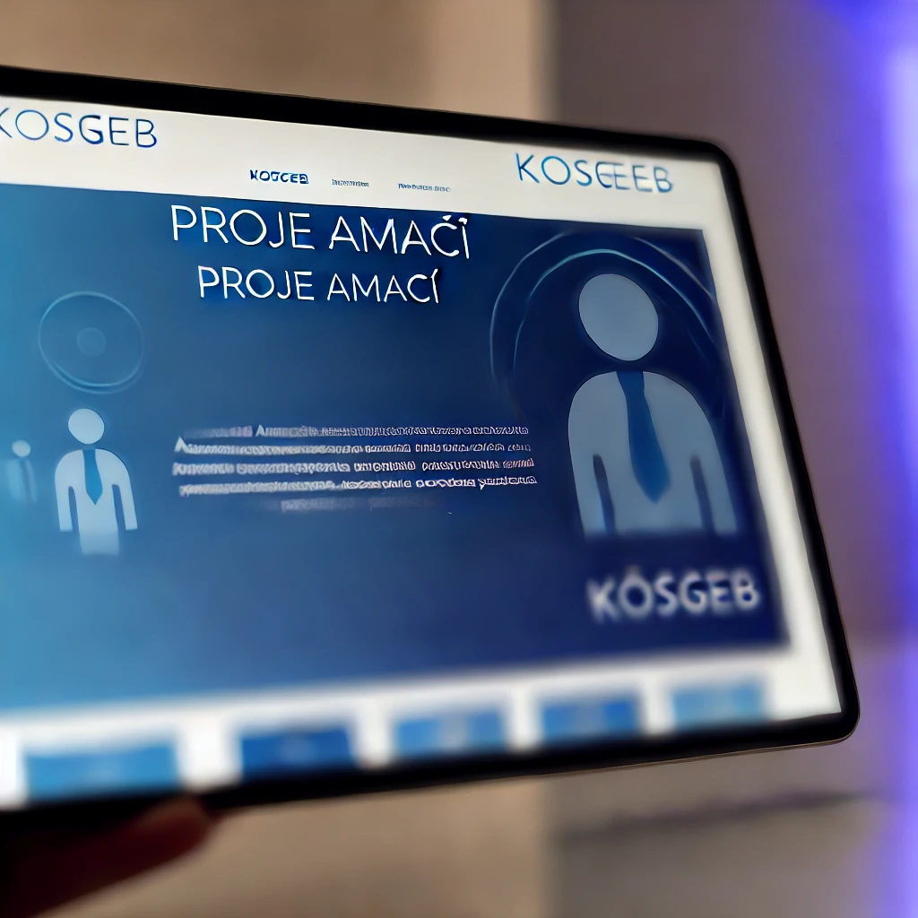

* **Project Purpose**  
  The general goal of the project is to solve targeted problems or take advantage of opportunities.
* **Project Objectives**  
  Specific and measurable outcomes of the project.
* **Innovative Aspects**  
  What makes the project innovative and unique compared to others?
* **Project Duration**  
  Estimated start and end dates provide insight into the project duration.
* **Project Personnel**  
  The roles and expertise of the people contributing to the project.
* **Project Budget**  
  The cost and budget items of the project.
* **Project Method and Application**  
  What methods and strategies will be used to execute the project?
* **Project Outputs**  
  The outputs and results to be achieved upon project completion.

### **What is the Purpose of Doing a Project?**



* Projects create new opportunities for business development.
* With KOSGEB support, you can finance your projects and help your business grow.

### **How Can I Improve My Business?**



* Analyze your current business, identify needs,
* Consider solutions,
* Increase production,
* Introduce new products,
* Advertise to attract more customers.

### **What is KOSGEB?**



* KOSGEB is an institution that provides support to small and medium-sized enterprises (SMEs).
* It is the most effective institution for SMEs in Turkey.
* Aims to increase the export share of SMEs,
* Aims to contribute to SME employment,
* You can apply for projects to obtain the necessary financing to develop your business.

### **What are the Benefits of KOSGEB Support for Businesses?**



* You receive financial support to implement projects faster and with lower risk.
* This support can be used for:
  + Purchasing new machinery,
  + Expanding your workplace, or
  + Marketing.

### **How Can I Apply to KOSGEB?**



* Register in the KOSGEB Database
* If registered, update your declaration
* Get information about the Support Program you want to apply for
* All applications are made online at www.kosgeb.gov.tr

### **What is a Business Plan?**



A business plan is a document that explains:

* What your business will do in the future,
* How it will generate revenue, and
* What it needs to do so.

A business plan is required for KOSGEB supports.

### **How Do I Prepare a Business Plan?**

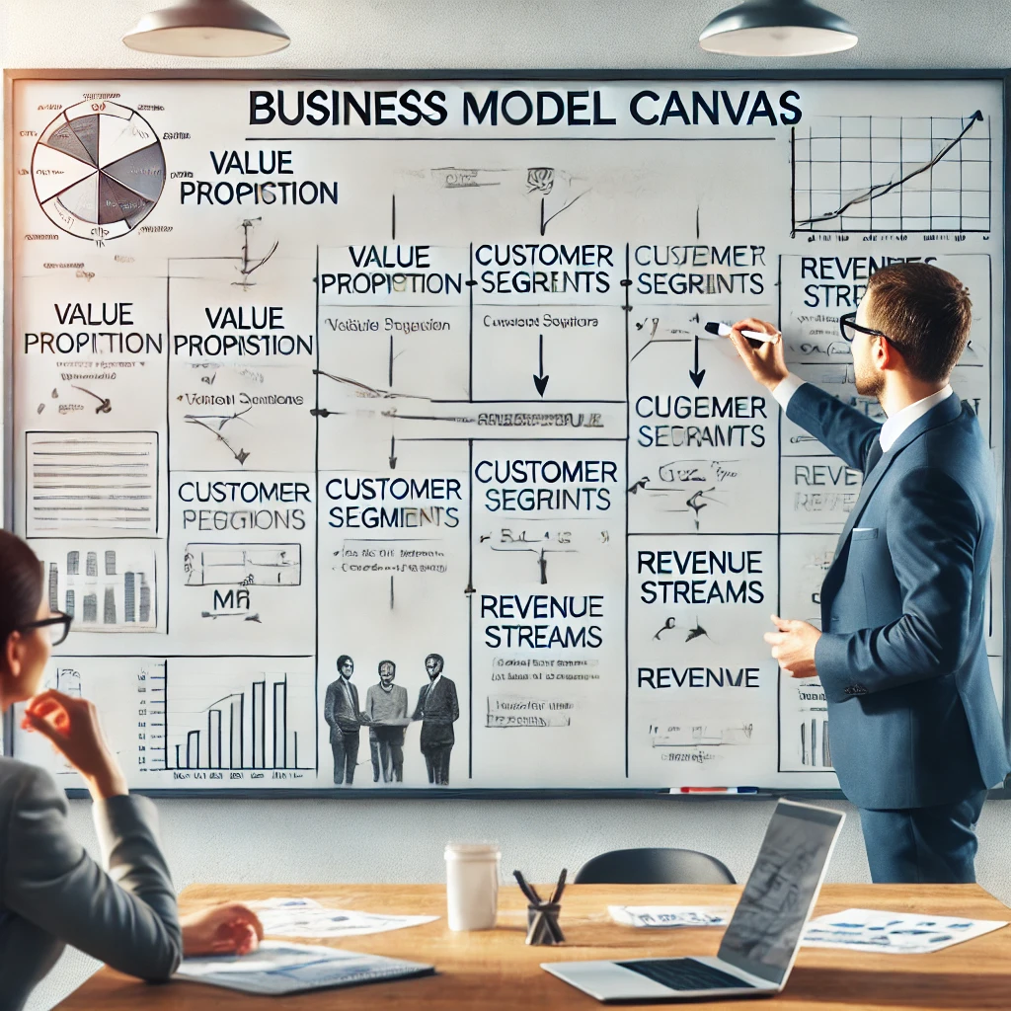

* Write down what your business will do,
* What product or service it will offer,
* Who it will target, and
* How you will implement this project.

### **Fill in the Business Plan (Project Information) Document**

* It defines the general framework of the supports provided to entrepreneurs by KOSGEB.

### **Business Information**

* Title
* Tax number
* Partners
* Organizational chart and personnel numbers and distribution
* Production site and facility information
* Production area
* Other projects and incentives from other institutions

### **Business Machine Inventory**

* Name of Machine/Equipment
* Quantity
* Domestic/Imported
* Specifications

### **Information About the Product Subject to the Project**

* Introduction of the product subject to the project.

### **Foreign Trade Data Regarding the Product Subject to the Project**

* Last 3 Years
  + Import Amount (USD)
  + Export Amount (USD)
  + Foreign Trade Deficit (USD)

### **Domestic and International Market Size of the Product**

* Last 3 Years
  + Domestic Market Size (Total Sales USD)
  + International Market Size (Total Sales USD)
  + Domestic Demand Quantity (Units)
  + Domestic Supply Quantity (Units)
  + International Demand Quantity (Units)
  + International Supply Quantity (Units)
  + Sector Growth Globally (%)

### **Export and Import Information Regarding the Product and Its Equivalent**

* Last 3 Years
  + Product Import (USD)
  + Equivalent Import (USD)
  + Product Export (USD)
  + Equivalent Export (USD)

### **Competitor Firms**

* Competitor Name
* Market Share (%)
* Strengths
* Weaknesses

### **Current and Potential Customers and Their Demands**

* Customer Information
* Predicted Customer Demands

### **Production-Sales Plan**

The production-sales plan is an important document that includes the production and sales targets of the business for a specific period. This plan includes:

* The costs of the products to be produced,
* Domestic and international sales prices,
* Estimated domestic and international sales quantities,
* Expected total sales revenues,
* Total costs,
* Expected profit.

This information plays a crucial role in determining the production capacity and marketing strategy of the business.

### **Investment Return Period**

The investment return period shows how long it will take to recover the investment made. The factors affecting this period include:

* Expected profit,
* Depreciation expenses,
* Total costs and revenues,
* Discount rate and present value,
* Investment amount and return period,
* Breakeven point (when revenues equal investment costs).

### **Business History, Current Activities, Partners, and Project Experiences**

* Business history
* Products produced as part of current activities
* Project experiences, along with the experience and education of the owner/partners
* Names and tax numbers of firms in which the applicant is also a partner

### **Current Situation Related to the Project**

* Current activities related to the project topic
* How current needs are being met
* Other studies

### **Purpose and Justification of the Project**

* Reasons why the project is needed
* Preparatory and technical feasibility studies conducted for the project
* Objectives of the project

### **Project Scope**

* Activities to be carried out within the scope of the project
* Impact of the project on the business’s:
  + Production/service provision capacity,
  + Product/service diversity,
  + Technology level,
  + Technical knowledge development,
  + Export potential,
  + Human resource quality.
* Solutions the project outcome addresses in the sector
* Applicability in other sectors

### **Project Goals and Activities**

* Project goals and activities should be explained with the following target cards.
* Under each goal:
  + Activities to be carried out to achieve the target,
  + Outputs of the activities listed in bullet points,
  + Project expenses related to each goal will be explained with justifications.
* Activity names written in this section will be the same as the activity names in the “3.1 Activity - Time Plan” section.

### **Impact of the Project on Goals, Market, and Competition**

* Medium and long-term goals of the business
* How the project will contribute to achieving these goals
* The project’s:
  + Impact on the business’s market share,
  + Market expansion,
  + Suitability of the project location logistically.

### **Risks, Measures, and Assumptions**

* Possible risks that may arise during and after the project implementation process
* Measures to be taken regarding these
* Assumptions that may positively affect the project implementation process

### **Business Resources to Be Used in the Project**

* To be used in the project:
  + Personnel owned by the business,
  + Machinery resources,
  + Expenditures to be made with the business’s own resources during the project process,
  + Their contribution to the project.

### **Project Management**

* Communication and coordination between the Project Manager and business managers, and relevant departments regarding:
  + How communication and coordination regarding the project will be ensured,
  + The review mechanism for project progress,
  + Task distribution related to KOSGEB project monitoring processes.
* In case of a Project Manager change, the project management should be structured in such a way that the project does not get disrupted.

### **Sustainability**

* How the sustainability of the expected results of the project will be ensured after project completion
* Explanation of sustainability both institutionally and financially.

### **Business Model Canvas**

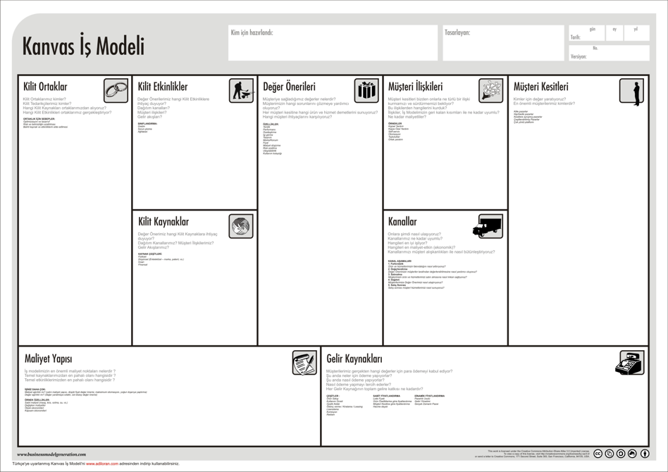

### **Evaluate Your Business with a SWOT Analysis**

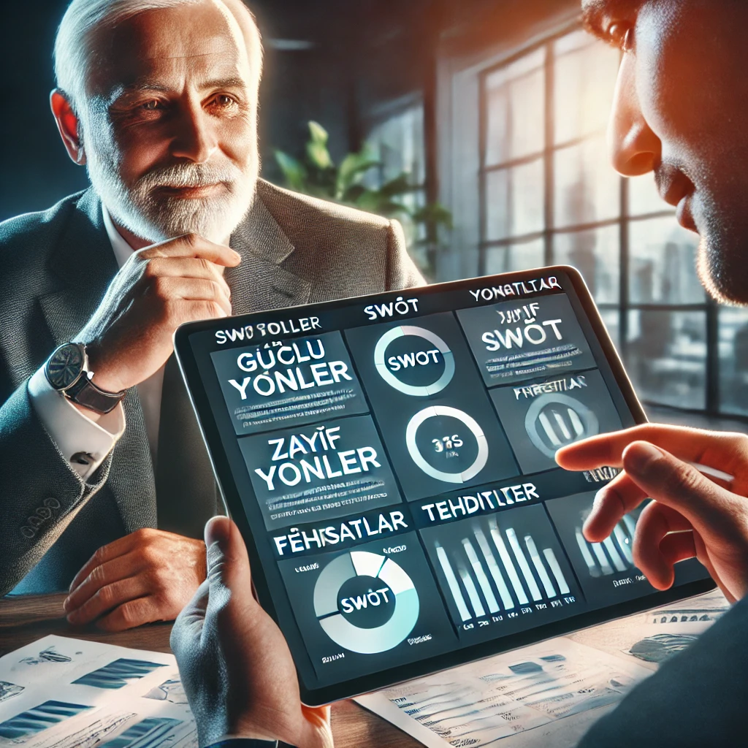

* What are your business’s strengths and weaknesses?
* You may have high customer satisfaction, but lack digital infrastructure.

Use SWOT to analyze the strengths and weaknesses of your business, and use the Business Model Canvas to create your business plan within a strategic framework.

#### **SWOT Table**

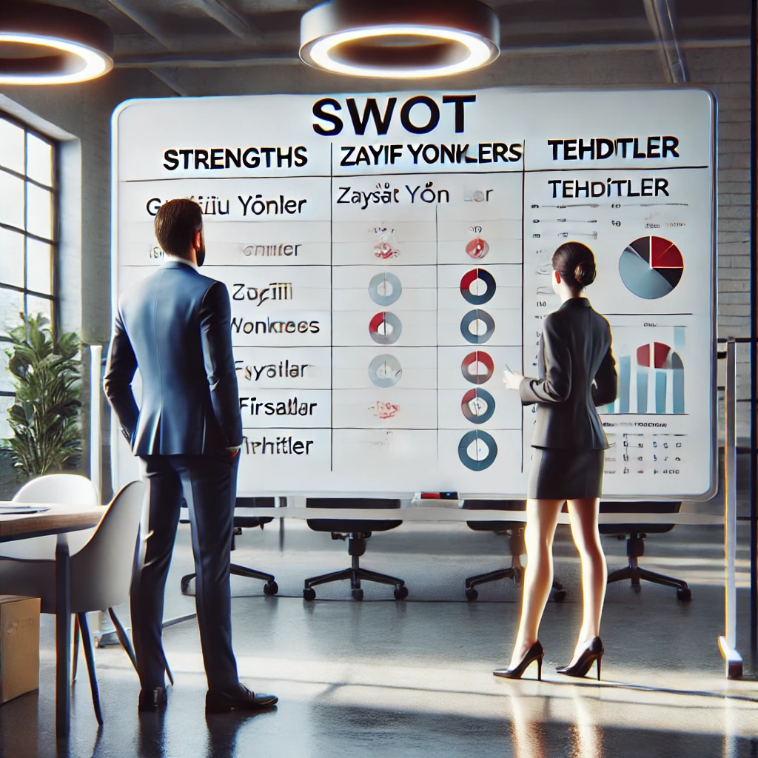

* **Strengths**: Quality products, customer loyalty.
* **Weaknesses**: Lack of digital infrastructure, insufficient marketing.
* **Opportunities**: Transition to online sales, new customer base.
* **Threats**: Increasing number of competitors, changing market dynamics.

# KOSGEB Support Programs from Idea to Market

    

* More information: [kosgeb.gov.tr](https://www.kosgeb.gov.tr)
* You can check out the Frequently Asked Questions page:
  + https://www.kosgeb.gov.tr/Web/Genel/SSS.aspx?KatID=2
* You can receive consultancy and support from chambers of commerce.

#### **Dr. Uğur CORUH**

* **General Manager, Coruh Arge ve Teknoloji**
* (ugur.coruh[*]coruh.com.tr)
* **Lecturer, Recep Tayyip Erdoğan University, Computer Engineering**
* (ugur.coruh[*]erdogan.edu.tr)

